CYB 300 Final Project

Douglas Few

April 24th 2022

Part One

The full script being run

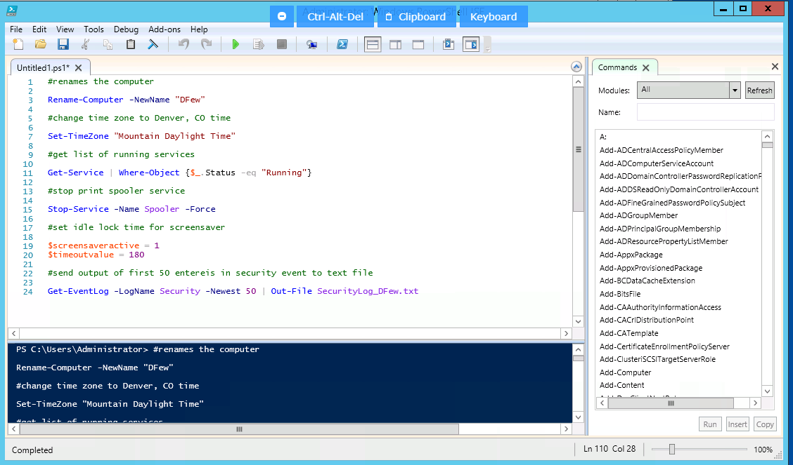

Rename Computer

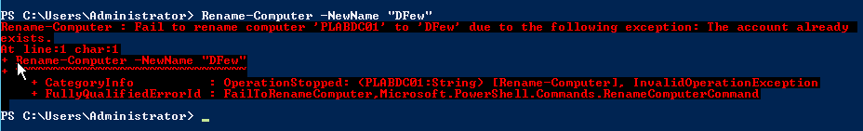

I’m assuming this failed because I already ran the command, so it already recognized the new name.

Change Time Zone



Get a list of currently running services

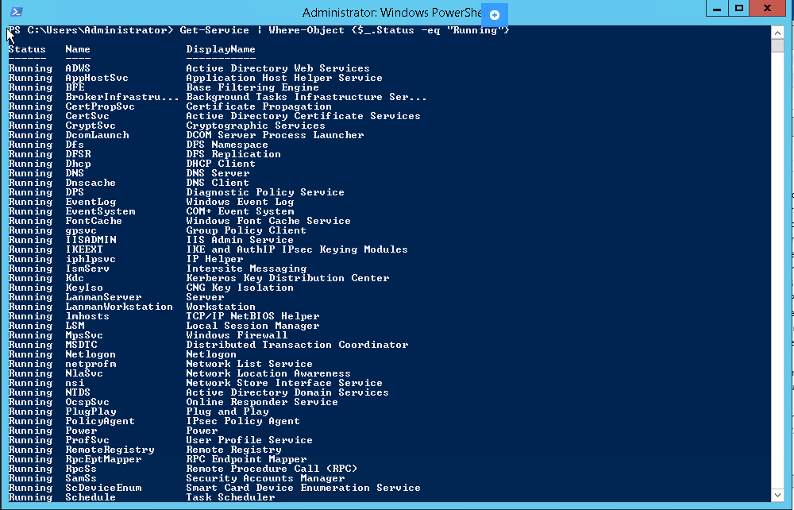

Stop Print Spooler Service



Set Idle Lock Time for Screensavers



Send output of 50 First Entries in Security Event to Text File

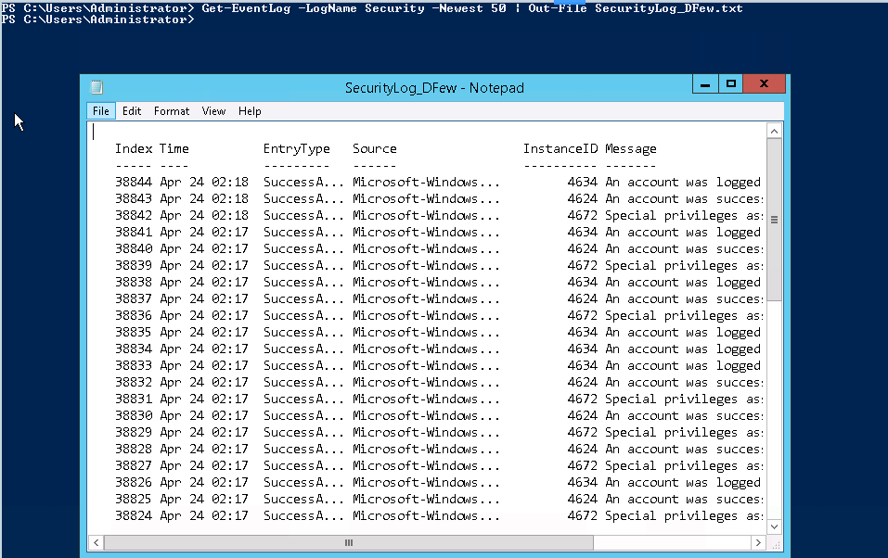

While the main benefit of automating scripts is the fact that it saves time when having to run them again in the future, in that the administrator does not have to rewrite every command each time, another benefit comes in the form of reproducibility. Knowing that the exact same script will be run each time helps the administrator to know that they are not missing or forgetting a vital component of their script. It also makes it easier to make changes to the script for future use, as there is already a foundation in place.

Part Two

Verification of Completed Certificate

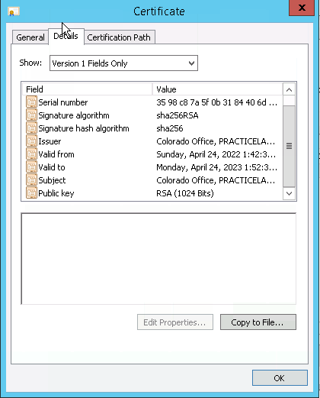

Part Three

When discussing making the transition from industry guidelines for network and system hardening to a baseline that is appropriate for our organization, I would recommend not straying too far from the industry standards. These guidelines are the standards for a reason, and typically are designed to provide the most amount of security possible. Of course, there will always be conflicting factors such as cost and time, but the security of the company and its assets should always be a major consideration when outlining an organization’s security.

Operating System Security-Configuration Checklist

| Rename Computer | Rename-Computer -NewName “new_name” |  |
| --- | --- | --- |
| Change Time Zone | Set-TimeZone “time zone name” |  |
| Get List of Running Services | Get-Service | Where-Object <$_.Status -eq "Running"> |  |
| Stop Print Spooler Service | Stop-Service -Name Spooler |  |
| Set Idle Lock Time | $screensaveractive = 1  $timeoutvalue = 180 |  |
| Output Event Log Entries to Text File | Get-EventLog -LogName Security -Newest 50 : Out-File <file_name> |  |

Operating system security-configuration checklists are an important part of the cybersecurity practices in an organization because it allows an administrator to create a plan for what needs to be accomplished. From that point, it also allows the administrator to easily follow what has already been accomplished and what tasks still need to be performed. The act of creating the checklist provides the administrator the opportunity to decide what tasks need to be completed and in what order, and the checklist itself can act as a guide through completing each task as an individual checks off each step.